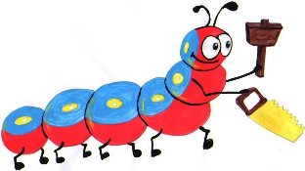

Lyng Primary School Knowledge Organiser

Design Technology

How can I construct a simple labyrinth using wood?

Year 5

Topic: DT

Spring

|  |  |
| --- | --- |
| What Goldilocks and Step On words will I use? | |
| **Spelling** | **Defintion** |
| Accurate | Neat, correct shape, size and pattern with no mistakes |
| Bench hook | A tool which hooks on to the bench used to hold wood work still when sawing |
| Hack saw | Fine toothed handsaw with a blade held under tension in a frame |
| File | A tool used to smooth rough edges on wood |
| Mark out | To measure and mark where a piece of material needs to be cut or shaped |
| Sandpaper | Strong paper with sand on one side to smooth or polish wood work |
| Set square | A right angled triangular plate used for drawing lines at 90 degrees. |



**Design Brief for pupils:**

* Design a labyrinth to be made from wood
* Use joining skills such as gluing
* Incorporate measuring and cutting skills
* Use a range of advanced tools such as a hack saw

**Purpose:** to construct a wooden model labyrinth

**Audience:** Individual use at school and home… and of course Daedalus

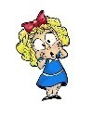

|  |
| --- |
| Skills and techniques |
| * Explore and evaluate a range of existing wooden products. * Explore different joining techniques in woodwork such as gluing. * Select appropriate tools and equipment to perform practical tasks such as marking out, cutting, joining and finishing. * Experiment with different finishing techniques e.g. using painting and varnishing. |

Spring Term

**Woodwork**

**Children will be taught** to accurately measure and mark a piece of wood before learning how to safely hold and use cutting equipment e.g. hacksaw and bench clamp. The children will cut wood before smoothing the edges with sandpaper for a good finishing effect. This will also assist with joining when they are required to glue pieces together. Children will learn to use right angles/right angle finders to attach wood perpendicularly.

**Agreed outcome:**

Construct a labyrinth linked to Theseus and the Minotaur

**Agreed outcome:**

A length of textile bunting created using children’s individual bunting triangles.